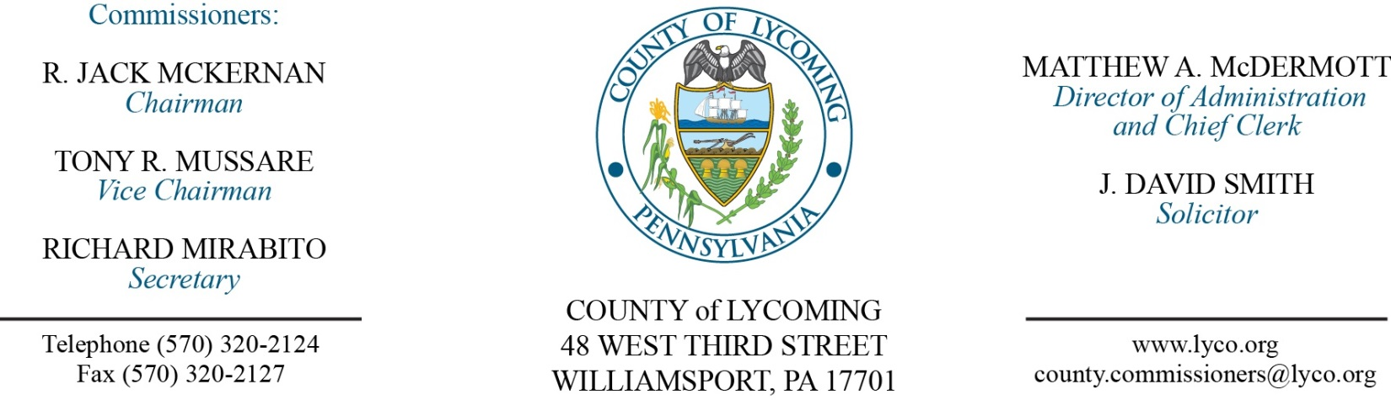
Commissioners’ Meeting Agenda
September 29, 2016

Opening Prayer

Pledge to the Flag

1.0 OPERATIONS

1.1 Convene Commissioners’ meeting.

1.2 Approve the minutes of the previous meetings.

1.3 Receive public comments (agenda items only).

2.0 ACTION ITEMS

2.1 Award contract for food products to Benjamin Foods LLC, Feesers Inc, Keyco Dist. Inc and Sysco Central Pennsylvania on a per item and as needed basis. (Mya Toon)

2.2 Approve revision to Policy 504.1 Travel and Business Related Expense Policy. (Mya Toon)

2.3 Amend the total purchase price of maintenance equipment for the White Deer Golf Course from TESCO & Finch as approved on June 9, 2016 from $149,980.63 to $158,430.17. (Mya Toon)

2.4 Approve purchase of 2 turbine blowers in the amount of $14,000 from Finch Services, Inc. for the White Deer Golf Course off of state contract. (Mya Toon)

2.5 Approve agreement with Tioga County for inmate housing in the amount of $60/inmate/day. (Mya Toon)

2.6 Approve professional service agreement with Keystone Communications LLC not to exceed $35,755.22. (Mya Toon)

2.7 Approve PEMA Radiation Emergency Response Fund Grant agreement in the amount of $5,876. (Kelle Robinson)

2.8 Approve 2015 904 recycling performance grant application for 2015 tonnage of 16,714.92. (Jason Yorks)

2.9 Approve professional service agreement with Larson Design Group for engineering services not to exceed $13,500. (Ken George)

2.10 Accept Human Resources report through September 30, 2016. (Lauren Bower)

2.11 Approve the following personnel actions: (Lauren Bower)
Prison – Kelly A. DeLand as full time replacement LPN – Pay grade 6 - $18.42/hour effective 10/3/16.
Pre-Release – Zachary O. McCloskey as full time replacement Resident Supervisor – Pay grade 5 - $15.07/hour effective 10/3/16.
Pre-Release – Coby M. Cotner as full time replacement Resident Supervisor – Pay grade 6 - $16.42/hour effective 10/3/16.

5.0 REPORTS/INFORMATION ITEMS

5.1 Present service pins:
10 years:
Jill Schriner DA.
Cathy Stosver – MDJ Solomon.
30 years:
Mark Murawski PCD.

5.2 Present award from AM Vets.

5.3 Present Five Star Service awards.

5.4 Lycoming County is requesting bids for sale of real property. (Mya Toon)

5.5 September 22, 2016 communications outage information. (John Yingling)

6.0 COMMISSIONER COMMENT:

7.0 PUBLIC COMMENT:

8.0 NEXT REGULARLY SCHEDULED MEETING: Planning Session on Tuesday, October 4, 2016.

9.0 ADJOURN COMMISSIONERS’ MEETING.

